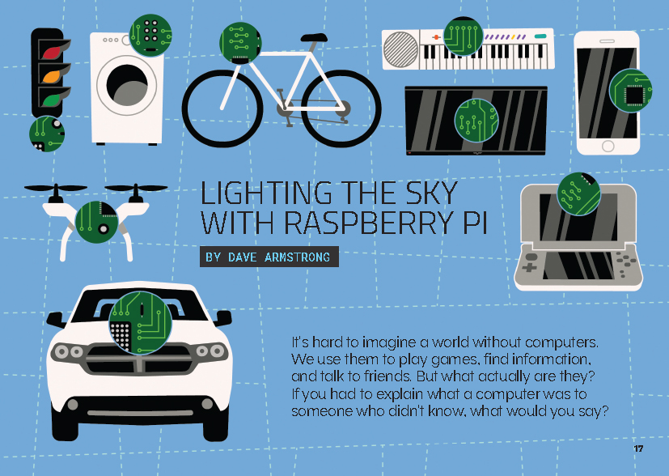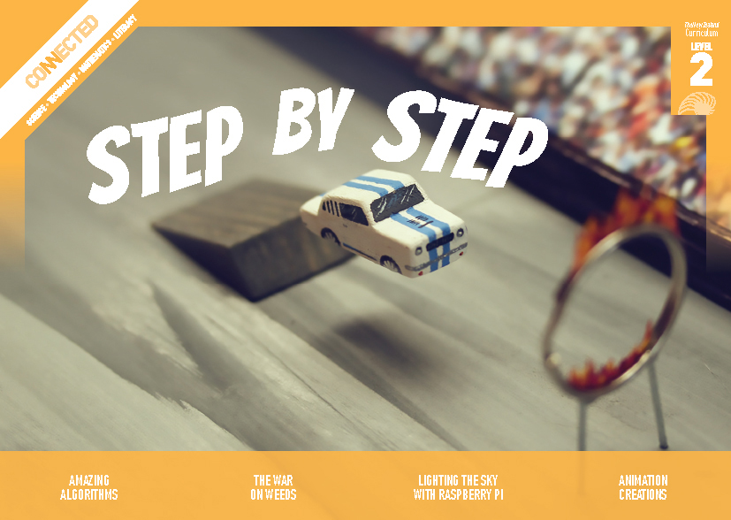

**Connected**

**Level 2**

**2018**

# Lighting the Sky with Raspberry Pi

by Dave Armstrong

|  |  |
| --- | --- |
| Overview This article describes how students at Fernridge School used Raspberry Pi computers to make a digital light display for Matariki. The narrative provides a context for building understanding about how computers work.  A Google Slides version of this article is available at [www.connected.tki.org.nz](http://www.connected.tki.org.nz.) |  |
| **Curriculum contexts** | |

|  |  |
| --- | --- |
| TECHNOLOGY: Technological Knowledge: Technological systems Level 2 – Students will understand that there are relationships between the inputs, controlled transformations, and outputs occurring within simple technological systems. Computational thinking for digital technologies: Progress outcome 1 In authentic contexts and taking account of end-users, students use their decomposition skills to break down simple non-computerised tasks into precise, unambiguous, step-by-step instructions (algorithmic thinking). They give these instructions, identify any errors in them as they are followed, and correct them (simple debugging). | Key technology ideas  * Computers are machines that process information. * Computer programs need to have precise instructions. * It may take several attempts to find solutions to problems. |
|  |  |
| ENGLISH: Reading Level 2 – Ideas: Students will show some understanding of ideas within, across, and beyond texts. | Indicators:  * uses their personal experience and world and literacy knowledge to make meaning from texts * makes meaning of increasingly complex texts by identifying main ideas * makes and supports inferences from texts with some independence. |
|  |  |
| MATHEMATICS and STATISTICS: Number and Algebra: Equations and expressions Level 2 – Students will communicate and interpret simple additive strategies, using words, diagrams (pictures), and symbols. | Key mathematics ideas  * Mathematicians use symbols, graphs, and diagrams to help them find and communicate patterns and relationships. * Mathematicians create models to represent both real-life and hypothetical situations. |
|  |  |

|  |  |
| --- | --- |
| SCIENCE: Physical World: Physical inquiry and physics concepts Level 2 – Students will explore everyday examples of physical phenomena, such as movement, forces, electricity and magnetism, light, sound, waves, and heat. | Key science ideas  * Electricity flows around a closed circuit. * Conductors allow electricity to flow through them; resistors restrict the flow of electricity; insulators do not allow the flow of electricity. |
|  |  |
| SCIENCE: Nature of Science: Investigating in Science Level 2 – Students will extend their experiences and personal explanations of the natural world through exploration, play, asking questions, and discussing simple models. Science capabilities This article provides opportunities to focus on the science capability: Engage with science. | Key Nature of Science ideas Scientists:   * make models to explain the natural world. |

|  |
| --- |
| [**The New Zealand Curriculum**](http://nzcurriculum.tki.org.nz/The-New-Zealand-Curriculum) |

|  |
| --- |
| [**Technology**](http://nzcurriculum.tki.org.nz/The-New-Zealand-Curriculum/Technology/) |

# Meeting the literacy challenges

|  |  |
| --- | --- |
| The main literacy demands of this text are in the abstract ideas and technical information regarding Raspberry Pi, programming, and electronic circuits. The biggest challenge is likely to be the names of the components and the acronyms, many of which will be unfamiliar to many students.  The text features photographs and diagrams to support students’ understanding of the scientific and technological concepts and processes. However, the diagrams themselves incorporate some acronyms and challenging technical vocabulary.  The article follows a procedure, told as a narrative. This surrounding narrative will support students to make sense of the more technical sections on how computers work. | The following strategies will support students to understand, respond to, and think critically about the information and ideas in the text. It may be appropriate to use all or only one or two of these strategies, depending on your students’ literacy knowledge and skills. You are encouraged to reword the suggested questions that will best suit your learners’ strengths and needs.  You may wish to use shared or guided reading, or a mixture of both, depending on the reading expertise of your students and the background knowledge they bring to the text. Given the literacy demands of this text, the suggestions below pre-suppose at least one shared reading before moving on to guided or independent reading.  After reading the text, support students to explore the activities outlined in the following pages. |
|  |  |
| INSTRUCTIONAL STRATEGIES |  |

|  |  |  |  |  |  |  |  |  |  |  |  |  |  |  |  |  |  |  |  |  |  |  |  |  |  |  |  |  |  |  |  |  |  |  |  |  |  |
| --- | --- | --- | --- | --- | --- | --- | --- | --- | --- | --- | --- | --- | --- | --- | --- | --- | --- | --- | --- | --- | --- | --- | --- | --- | --- | --- | --- | --- | --- | --- | --- | --- | --- | --- | --- | --- | --- |
| Finding the main ideas Read the title out loud and allow the students to speculate on what the story is about. Then EXPLAIN that this article is about a class of students who learnt how use a computer to create a light display representing Matariki. PROMPT the students to make connections to their prior knowledge about computers, Matariki, and electrical circuits.  What do you know about Matariki? Why might someone want to create a light display of Matariki?  How do you use computers in your daily life?  What exactly is a computer? Could you explain it to somebody else? Turn to your partner and see how you go!  What do you know about light and electricity? Can anyone explain how an electric light works?  Tell the students that this is quite a tricky article. If you are not particularly familiar with this topic, share this with the students and say that because of this, you will be learning together.  If you have access to an actual Raspberry Pi, let the students examine it and predict how it might be used to show how computers work. Students who belong to a coding club may be able to explain how they used a Raspberry Pi.  Plan a reading approach with the students. You might read the article very slowly, taking time to unpack the diagrams and language, or you might focus on the written text and big ideas first and then pull the written text together with the visual information during a guided reading session. (These notes support either approach.)  On our first reading, let’s not worry too much about understanding everything. Let’s get the big ideas and then go back and get to grips with the detail. | Introduce the use of an [anticipation guide](http://serpmedia.org/rtls/anticipation.html). EXPLAIN that the purpose of an anticipation guide is to help us focus on the most important ideas in a text. Before the reading, the students are to decide which of the statements below are true and which are false. As the students read, they are to IDENTIFY when there is evidence for or against one of the statements. Afterwards, they can reassess their judgments, supporting their final decisions with evidence from the text.  Please note that suggested statements are provided below, along with the answers, but feel free to make up your own.   |  |  |  |  |  |  | | --- | --- | --- | --- | --- | --- | | Statements | What I think | | What the text says | | Evidence from the text | | Students can make their own digital technologies. [True] | True | False | True | False |  | | An electric circuit always needs a switch. [False] | True | False | True | False |  | | An algorithm is a list of instructions that say what to do and when. [True] | True | False | True | False |  | | The information that Scratch passed on to Raspberry Pi is an example of an input. [False] | True | False | True | False |  | |  |  |  |  |  |  | |

## Meeting the literacy challenges

|  |  |  |  |  |  |  |  |  |  |  |  |  |  |  |  |  |
| --- | --- | --- | --- | --- | --- | --- | --- | --- | --- | --- | --- | --- | --- | --- | --- | --- |
| Dealing with unfamiliar vocabulary  Prior to the reading, EXPLAIN that the text includes a lot of technical words and acronyms that people may not find familiar. PROMPT the students to recall their strategies for working out the meanings of unfamiliar words, including:   * using the glossary * inferring meaning from the surrounding text * noticing that the writer has explained some words inside the text * using information from the visual imagery * inferring meaning from known roots and affixes * looking words up in a dictionary.   Note that sometimes these tried-and-true methods can break down when we’re faced with unfamiliar technical vocabulary. As digital technology develops, so does the vocabulary to describe it (for example, googling, blogging, vlogging, hashtags, hyperlinks, and so on).  It turned out a Raspberry Pi wasn’t a dessert. What was the “breadboard”? How do you think the digital breadboard got its name?  If necessary, explain that an acronym is a special kind of abbreviation that is made up of the first letters of other words, for example, LOL.  What were the acronyms in this text? What do you think they mean?  Use a dictionary or do an online search to find the actual meanings of these acronyms. Were you right?  Why do you think the author has used acronyms? Do they make it easier or harder to make sense of the text?  Now that you feel more confident about what these acronyms mean, what happens when you reread a part that you found tricky before?  Have the students use a table like the one below to show that they understand the concept of digital technologies and the difference between *using* and *creating* digital technologies. They can test their explanations – and practise using the words – by talking through their explanations and examples with a partner. It is suggested that you model this activity with your students first.   |  |  |  | | --- | --- | --- | | Term | Your explanation | Examples | | Digital technologies |  |  | | Being a *user* of digital technologies |  |  | | Being a *creator* of digital technologies |  |  | |  |  |  | | The word “program” provides the opportunity to talk about how the English language changes over time and in different places. EXPLAIN that in New Zealand and Britain, we use “program” for talking about computer programs and “programme” for all other types of programmes. In the United States, people always use the spelling “program”. Using design features for deeper understanding Ask the students what they can tell you about the photographs on page 18. PROMPT any technical experts in the class to share their knowledge. After the students have looked closely at the other diagrams in the rest of the article, have them return to these photographs and talk through them again, drawing on their new vocabulary and understandings.  Check that the students can identify the three key items in front of the students on page 19 – the Raspberry Pi, the breadboard, and the LED bulbs.  ASK QUESTIONS to check that the students understand how an electrical circuit works. After reading page 20, ask:   * Why is the light not on in the first diagram? Why is it on in the second diagram? * How does the switch work?   Have the students sketch the right-hand diagram on page 20, adding labels for its four components, along with explanations of their purpose. They can swap with a partner to check that they are correct.  It’s likely that many students will find the diagram on page 21 quite challenging – but it is key to understanding the concepts.   * Check that the students can match the numbered steps below the diagram on the left-hand side to the diagram on the right-hand side. * Check that they understand how the right-hand diagram summarises what we see, without the complexity of the labelling. * Give the students printouts of the procedure and the unlabelled diagram. Have them match the text to the diagram. * Check that the students have correctly matched the text to the diagrams, then have them talk through the procedure with a partner. Depending on their confidence with the topic, and with the English language, they could do this with the support of the original text, key words, or with no written text at all. |
|  |  |

## Meeting the literacy challenges

|  |  |
| --- | --- |
| Model how to interpret the diagram on page 22, explaining what you can see, what the instructions are saying, and how that is reflected in the picture. Clarify any misconceptions.  Model or have a student talk through the diagram on page 23, explaining how the algorithm tells the Raspberry Pi computers that it wants the seven lights to flash in sequence. Invite the other students to help you clarify any misconceptions. Have the students work in pairs to test each other’s understandings. They are to do this by taking turns masking the instructions for one of the LEDs and having their partner write the instruction.  Ask the students what we learn from the diagrams and text in the sidebar on page 24. Can they respond correctly to the writer’s question? |  |

|  |  |
| --- | --- |
| TEACHER RESOURCES |  |

|  |  |
| --- | --- |
| Want to know more about instructional strategies? Go to:   * <http://literacyonline.tki.org.nz/Literacy-Online/Planning-for-my-students-needs/Effective-Literacy-Practice-Years-1-4> * “Engaging Learners with Texts” (Chapter 5) from *Effective Literacy Practice in Years 1 to 4* (Ministry of Education, 2003).   Want to know more about what literacy skills and knowledge your students need? Go to:   * <http://nzcurriculum.tki.org.nz/Assessment/Reading-and-writing-standards> * <http://www.literacyprogressions.tki.org.nz/> | We have retained the links to the National Standards while a new assessment and reporting system is being developed. For more information on assessing and reporting in the post-National Standards era, see:   * <http://assessment.tki.org.nz/Assessment-and-reporting-guide> |

|  |  |  |
| --- | --- | --- |
|  | [**Reading standard: by the end of year 4**](http://nzcurriculum.tki.org.nz/National-Standards/Reading-and-writing-standards/The-standards/End-of-year-4) | |
|  | | |
|  | [**The Literacy Learning Progressions**](http://www.literacyprogressions.tki.org.nz/The-Structure-of-the-Progressions/By-the-end-of-year-4?q=node/14) | |
|  |  |
|  | [**Effective Literacy Practice: years 1–4**](http://literacyonline.tki.org.nz/Literacy-Online/Planning-for-my-students-needs/Effective-Literacy-Practice-Years-1-4) | |

## Illustrating the key ideas

|  |  |
| --- | --- |
| TEACHER SUPPORT |  |
| There are relationships between the inputs, controlled transformations, and outputs within simple technological systems.    An algorithm is precise step-by-step instructions to complete a task or solve a problem.  Computer programs need to have precise instructions. | |
|  | [Grab your reader’s attention with a great quote from the document or use this space to emphasize a key point. To place this text box anywhere on the page, just drag it.] |

# Learning activities – Exploring the science, technology, and mathematics and statistics

The following activities and suggestions are designed as a guide for supporting students to explore and extend student content knowledge across the learning areas. Adapt these activities to support your students’ learning needs.

|  |  |
| --- | --- |
| Activity 1 – Give it a go! Students will be keen to have a go at using [Raspberry Pi](http://www.raspberrypi.org/) and [Scratch](https://scratch.mit.edu/) for a project of their own. If you’re not comfortable with supporting this, there are places where you can get support:   * [Code Club Aotearoa](https://codeclub.nz/) offers free advice and resources, including step-by-step instructions for creating projects using Raspberry Pi and Scratch. Their staff and volunteers can help. You can even apply for free teacher training. * Fernridge School was part of a professional learning project that helped a group of schools prepare to teach the digital technologies curriculum. You can access the teaching and learning materials they used from the [Technology Hub Resource Library](https://digitaltechnologies.net.nz/resource-library/). The project was aimed at introducing fundamental digital technologies concepts to students in years 6–8, so you would need to adapt the ideas to your students in year 4. It would help to have access to Raspberry Pi, but it is not essential. * Raspberry Pi’s own site contains resources for teaching, learning, and using Raspberry Pi. * [Australia’s Digital Technologies Hub](https://www.digitaltechnologieshub.edu.au/teachers/topics/computational-thinking) offers learning resources and services for teachers, students, school leaders, and parents, including introductions to computational thinking and coding. * [Lifehacker Australia](http://www.lifehacker.com.au/2017/01/top-10-raspberry-pi-projects-for-beginners/) has fun Raspberry Pi projects for beginners. It includes videos that students could use to create step-by-step instructions that they could then improve as they try the projects for themselves.  Activity 2 – Understanding circuits Students could investigate other electrical circuits.  *Making Better Sense of the Physical World* has a chapter on electricity that includes activities for learning about circuits. Students explore circuit diagrams and make their own simple circuits.  Building Science Concepts book 49, *Invisible Forces: Magnetism and Static Electricity*, helps students to understand the relationship between static and current electricity and between magnetism and electricity. Book 10, *Light and Colour: Our Vision of the World*,supports learning about the physical phenomena of light and how light forms patterns as it travels, which we interpret as sight and colour. | [The Science Learning Hub](http://www.sciencelearn.org.nz/resources/2514-measuring-humidity-and-temperature-with-a-raspberry-pi) offers an activity in which students use Raspberry Pi and other electronic components to measure temperature and humidity levels in houses that they have modelled from ice cream containers. They use data from the sensors to determine whether ventilation helps to reduce dampness.  You could use [Squishy Circuits](http://squishycircuits.com/) as a playful way to introduce LEDs. Extension Students could explore how lighting is used in other activities or contexts that are familiar to them. For example, they could consider how lighting is used in cultural celebrations, such as Chinese New Year and Diwali, and how they could make a light display that contributes to the celebration. |
| Activity 3 – Let it flow Discuss the features of a flow diagram and, if necessary, demonstrate a simple example (for example, a procedure for making a cup of tea). Have the students create flow diagrams to represent the procedure the students at Fernridge School followed to create their light display. Have the students evaluate each other’s diagrams according to whether somebody reading the diagram would be able to understand:   * the students’ goal * the steps that need to be undertaken to achieve the goal * the sequence of steps * how each step links to the other steps.   Discuss how we use flow diagrams right across the curriculum.  How can we use a flow diagram in other parts of our learning together?  What are some features of a good flow diagram?  Can you create a flow diagram to illustrate how to create a good flow diagram? |

# Learning activities – Exploring the science, technology, and mathematics and statistics

|  |  |
| --- | --- |
| RESOURCE LINKS |  |

|  |  |
| --- | --- |
| Building Science Concepts Book 10 – *Light and Colour: Our Vision of the World*  Book 28 – *The Night Sky: Patterns, Observations, and Traditions*  Book 49 – *Invisible Forces: Magnetism and Static Electricity  (L3–4)* School Journal “Tunç Tezel: Star Man”, *School Journal* Level 2, May 2016  “Celebrating Puanga at Ramanui”, *School Journal* Level 2, November 2017 Science Learning Hub Measuring humidity and temperature with a Raspberry Pi: [www.sciencelearn.org.nz/resources/2514-measuring-humidity-and-temperature-with-a-raspberry-pi](https://www.sciencelearn.org.nz/resources/2514-measuring-humidity-and-temperature-with-a-raspberry-pi)  Resistors: [www.sciencelearn.org.nz/resources/1605-resistors](https://www.sciencelearn.org.nz/resources/1605-resistors) Other sources Code Club Aotearoa: <https://codeclub.nz/>  Digital Technologies Hub (Australia) – Computational thinking: [www.digitaltechnologieshub.edu.au/teachers/topics/computational-thinking](https://www.digitaltechnologieshub.edu.au/teachers/topics/computational-thinking)  Digital Technologies Hub (Australia) – General-purpose programming/coding: [www.digitaltechnologieshub.edu.au/teachers/topics/general-purpose-programming-coding](https://www.digitaltechnologieshub.edu.au/teachers/topics/general-purpose-programming-coding) | Lifehacker (Australia) – Top 10 Raspberry Pi projects for beginners: [www.lifehacker.com.au/2017/01/top-10-raspberry-pi-projects-for-beginners/](https://www.lifehacker.com.au/2017/01/top-10-raspberry-pi-projects-for-beginners/)  National Library of New Zealand – Any questions (Matariki): <https://anyquestions.govt.nz/many_answers/matariki>  Technology Hub Resource Library: <https://digitaltechnologies.net.nz/resource-library/>  Squishy circuits: <http://squishycircuits.com/>  Raspberry Pi: [www.raspberrypi.org/](https://www.raspberrypi.org/)  Technology Online – Learning digital technologies in years 6–9 with Raspberry Pi: <http://technology.tki.org.nz/Technology-in-the-NZC/Digital-technologies-curriculum-support/Strengthening-digital-technologies/Learning-with-Raspberry-Pi>  TKI case study – New Lynn School: <http://nzcurriculum.tki.org.nz/Curriculum-stories/School-snapshots/New-Lynn-School>  Scratch: <https://scratch.mit.edu/> |

